7-2 Project Two Submission

Felix Bacot Mena
Southern New Hampshire University
CS – 340 Client/Server Development 2026
Professor: Dr. Helen Gebre-Amlak
June 17, 2026

Grazioso Salvare identifies dogs that are suitable candidates for search-and-rescue training. These dogs are trained to locate and assist humans or animals in life-threatening situations. Grazioso Salvare has partnered with a non-profit organization that operates five animal shelters in the Austin, Texas area. Through this partnership, Grazioso Salvare receives shelter data that can be used to identify potential rescue dogs.
Research conducted by Grazioso Salvare has determined that certain breeds, ages, and sexes are more effective for specific rescue operations, including water rescue, mountain or wilderness rescue, and disaster or individual tracking. To support this effort, Grazioso Salvare requested a dashboard application that allows users to search, filter, and visualize shelter data stored in a MongoDB database.
The objective of this project was to develop a user-friendly dashboard that enables Grazioso Salvare personnel to quickly identify dogs that meet the organization's rescue training criteria while minimizing user errors and reducing training requirements.

Dashboard Branding
The dashboard includes the required branding elements specified by Grazioso Salvare:
- Grazioso Salvare logo displayed prominently at the top of the dashboard.
- Unique identifier displaying the dashboard creator's name: Felix Bacot Mena.
- Interactive dashboard interface designed for ease of use and intuitive navigation.

Required Functionality
The dashboard includes the following required functionality:
- Interactive filtering options using radio buttons
- Interactive data table displaying Austin Animal Center records
- Dynamic bar chart displaying animal breed counts
- Interactive geolocation map displaying animal locations
- Grazioso Salvare logo displayed on the dashboard
- Unique identifier displaying the student’s name
- Reset option to restore the full dataset

Interactive Data Table
The dashboard contains a data table that displays Austin Animal Center records retrieved from MongoDB. The table updates automatically based on the selected rescue category.
Features include:
- Single-row selection
- Dynamic filtering
- Interactive highlighting
- Sortable columns
- Paginated results

Geolocation Map
A Dash Leaflet geolocation map displays the location of selected animals using latitude and longitude coordinates from the dataset.
The map updates automatically whenever a user selects a row from the data table.

Breed Distribution Bar Chart
A dynamic bar chart was developed using Plotly Express to display the distribution of dog breeds within the selected rescue category.
The chart updates automatically whenever a filter option is selected.

Rescue Category Queries
The dashboard utilizes MongoDB queries based on Grazioso Salvare's rescue dog requirements.

Water Rescue
Preferred Breeds:
- Labrador Retriever Mix
- Chesapeake Bay Retriever
- Newfoundland
Preferred Sex:
- Intact Female
Training Age:
- 26 to 156 weeks

Mountain or Wilderness Rescue
Preferred Breeds:
- German Shepherd
- Alaskan Malamute
- Old English Sheepdog
- Siberian Husky
- Rottweiler
Preferred Sex:
- Intact Male
Training Age:
- 26 to 156 weeks

Disaster or Individual Tracking
Preferred Breeds:
- Doberman Pinscher
- German Shepherd
- Golden Retriever
- Bloodhound
- Rottweiler
Preferred Sex:
- Intact Male
Training Age:
- 20 to 300 weeks

Reset
Returns the dashboard to its original unfiltered state and displays all available animal records.

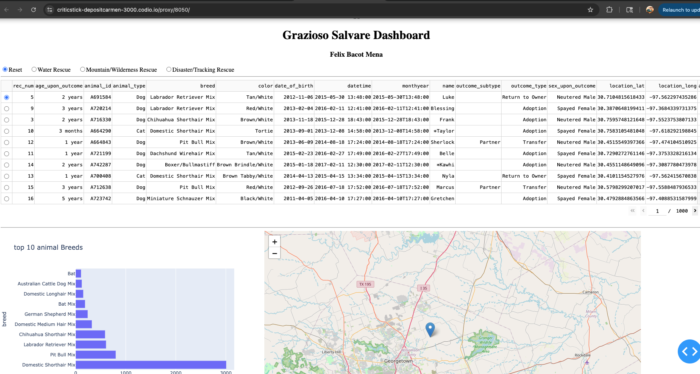
Water Rescue Filter
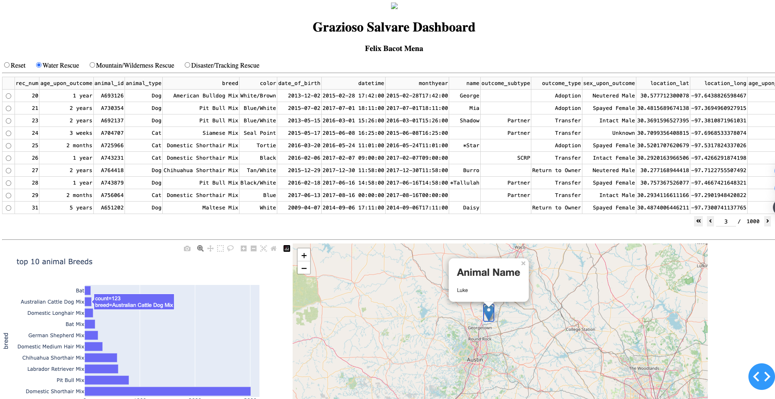

Mountain/Wilderness Rescue Filter
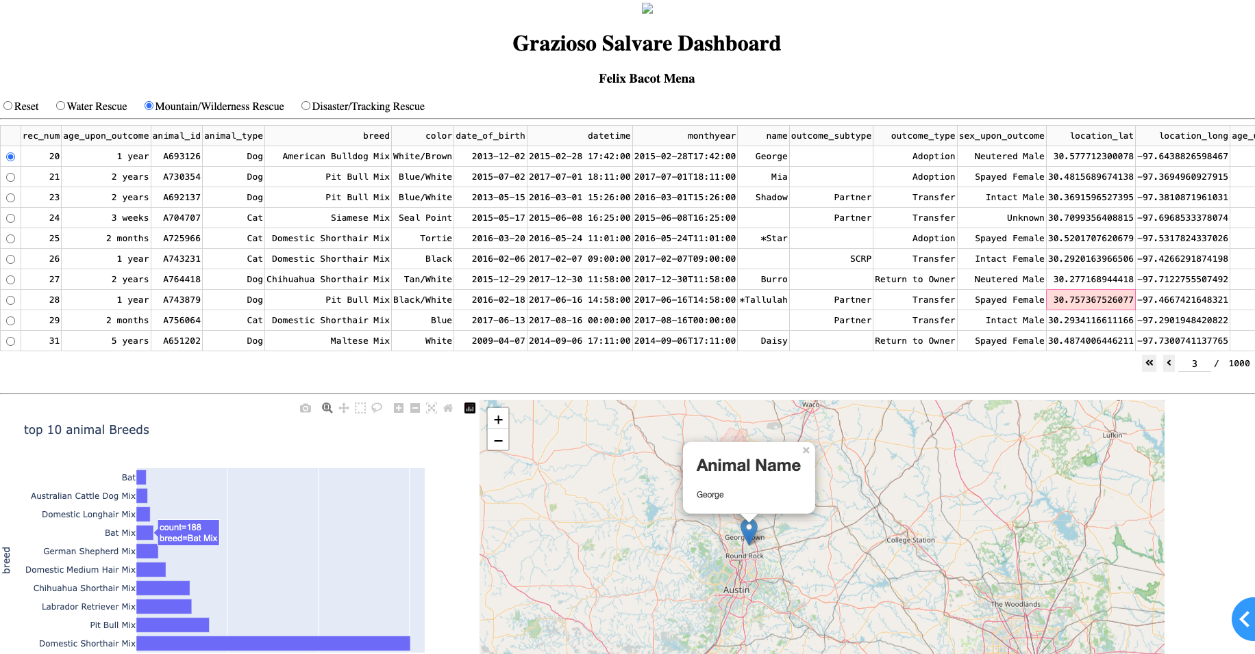

Disaster/Tracking Rescue Filter
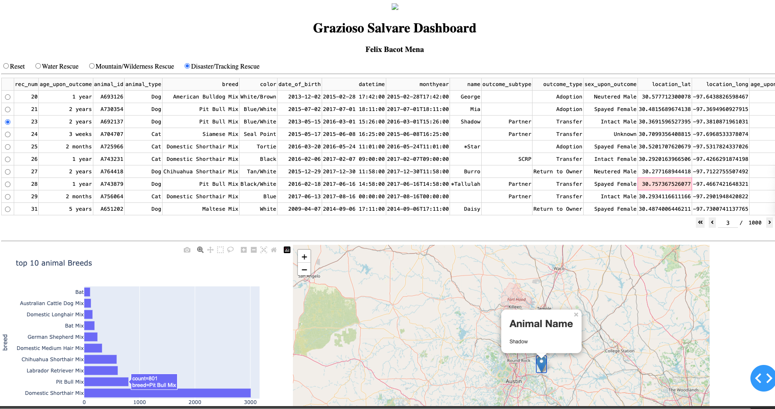

Tools and Technologies Used

MongoDB
MongoDB was used as the database management system for storing and retrieving Austin Animal Center animal records.
Reasons for selecting MongoDB:
- Flexible document-based data model
- Efficient querying and filtering capabilities
- Easy integration with Python through the PyMongo library
- Supports large datasets and scalable applications

Python
Python was used as the primary programming language for developing the CRUD module and dashboard functionality.
Reasons for selecting Python:
- Strong MongoDB support through PyMongo
- Extensive data analysis libraries
- Easy integration with Dash
- Simplified object-oriented programming

Dash Framework
The Dash framework was used to create the dashboard user interface and manage user interactions.
Reasons for selecting Dash:
- Built specifically for Python developers
- Supports interactive web applications
- Integrates seamlessly with Plotly visualizations
- Provides callback functions for dynamic updates

Plotly Express
Plotly Express was used to create the interactive bar chart.
Benefits:
- Easy chart creation
- Interactive visualizations
- Seamless integration with Dash

Dash Leaflet
Dash Leaflet was used to display geographic animal locations on an interactive map.
Benefits:
- Interactive mapping capabilities
- Real-time updates from selected records
- Easy integration with dashboard components

Project Development Steps

Step 1: Create MongoDB Database
- Imported Austin Animal Center dataset into MongoDB.
- Created the aac database and animals collection.
- Verified successful data import.

Step 2: Develop CRUD Module
- Created AnimalShelter.py.
- Implemented Create functionality.
- Implemented Read functionality.
- Implemented Update functionality.
- Implemented Delete functionality.
- Tested all CRUD operations.

Step 3: Build Dashboard Layout
- Added Grazioso Salvare logo.
- Added dashboard title.
- Added unique identifier displaying student name.
- Created interactive data table.

Step 4: Add Interactive Filters
Implemented radio button filters for:
- Water Rescue
- Mountain/Wilderness Rescue
- Disaster/Tracking Rescue
- Reset

Step 5: Create Dynamic Visualizations
- Developed a dynamic bar chart displaying animal breed counts.
- Implemented an interactive geolocation map.
- Connected visualizations to dashboard filters.

Step 6: Test Dashboard
- Verified dashboard loading.
- Verified MongoDB connectivity.
- Verified filter functionality.
- Verified bar chart updates.
- Verified map updates.
- Verified data table updates.

Challenges Encountered
Several challenges were encountered during project development.

Challenge 1: Dashboard Syntax Errors
Issues encountered:
- Missing commas
- Incorrect parentheses
- Incorrect indentation
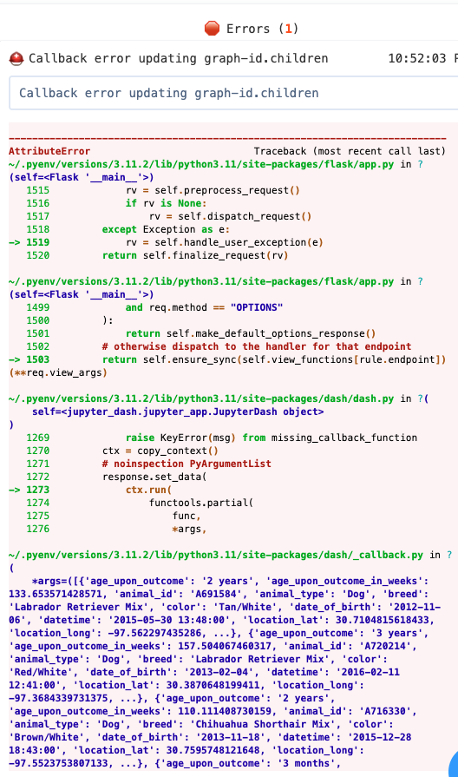
Solution:
- Carefully reviewed code structure.
- Corrected syntax issues.
- Tested code incrementally.

Challenge 2: Callback Errors
Issues encountered:
- Incorrect component IDs
- Mismatched callback references
- Undefined variables
Solution:
- Verified component IDs matched callback references.
- Corrected variable naming errors.
- Updated callback functions.

Challenge 3: Data Visualization Issues
Issues encountered:
- Pie chart labels overlapping due to excessive breed categories.
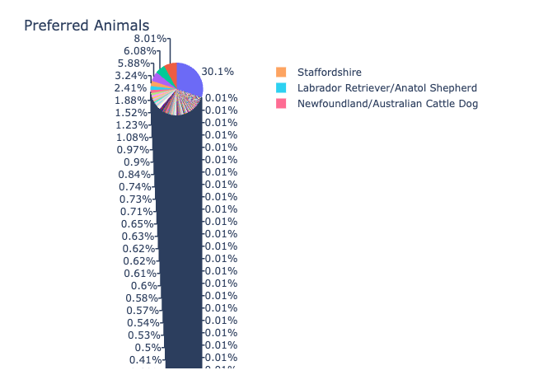
Solution:
- Replaced pie chart with a horizontal bar chart.
- Limited displayed breeds to improve readability.

Challenge 4: MongoDB Integration
Issues encountered:
- Authentication configuration
- CRUD module connectivity
Solution:
- Verified database credentials.
- Updated MongoDB connection strings.
- Successfully tested CRUD operations.

Contact
Thank you for reviewing this project. If you have any questions regarding the dashboard application, CRUD module, or the implementation of this project, please feel free to contact me.
Student: Felix Bacot Mena
Course: CS-340 Client/Server Development
Institution: Southern New Hampshire University
GitHub Portfolio:
https://github.com/Felix-Bacot
Email: felix.bacotmena@snhu.edu

Conclusion
This project successfully delivered a fully functional web application dashboard for Grazioso Salvare. The dashboard provides interactive filtering, dynamic visualizations, and geolocation mapping capabilities using MongoDB, Python, Dash, Plotly, and Dash Leaflet. The final solution demonstrates the practical application of client/server development principles and the Model-View-Controller architecture while providing an intuitive interface for rescue animal data analysis.

